Solving Systems of Linear Equations

Key Points:
- A system of linear equations consists of two or more equations made up of two or more variables such that all equations in the system are considered simultaneously.

For example, $\begin{matrix}2x+y=15 \\ 3x-y=5\end{matrix}$ is a system of linear equations in two variables.

- The solution to a system of linear equations in two variables is any ordered pair that satisfies each equation independently.

In the above example, the order pair $\left(4,7\right)$ is the solution to the system of equations
$$\begin{matrix}2\left(4\right)+7=15 \\ 3\left(4\right)-7=5\end{matrix}$$

- There are three types of systems of linear equations in two variables, and three types of solutions:

  - An Independent System has exactly one solution pair $(x,y)$ The point where the two lines intersect is the only solution.
  - An Inconsistent System has no solution. Notice that the two lines are parallel and will never intersect.
  - A Dependent System has infinitely many solutions. The lines are coincident. They are the same line, so every coordinate pair on the line is a solution to both equations.
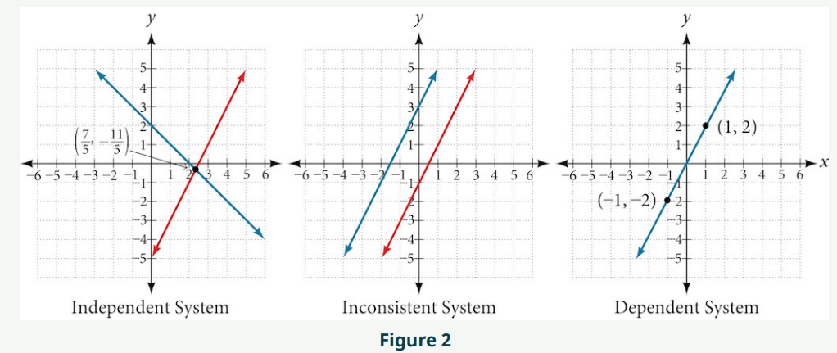

- One method of solving a system of linear equations in two variables is by graphing. In this method, we graph the equations on the same set of axes.

- Another method of solving a system of linear equations is by substitution. In this method, we solve for one variable in one equation and substitute the result into the second equation.

- A third method of solving a system of linear equations is by elimination, in which we can eliminate a variable by adding opposite coefficients of corresponding variables.

Solving Systems of Linear Equations Video
- Determining whether an Ordered pair Is a Solution to a Systems of Equations
- Solving Systems of Linear Equations by Graphing
- Solving Systems of Linear Equations in Two Variables by Substitution
- Solving Systems of Linear Equations in Two Variables by the Elimination Method
- Identifying Inconsistent Systems of Equations Containing Two Variables
- Expressing the Solution of Systems of Dependent Equations Containing Two Variables

Practice Exercises

Follow the instructions for each of the following exercises.

- Determine whether the ordered pair is a solution to the system of equations:
$$3x-y=4$$
$$x+4y=-3$$
$$(-1,1)$$

- Determine whether the ordered pair is a solution to the system of equations:
$$6x-2y=24$$
$$-3x+3y=18$$
$$(9,15)$$

- Use substitution to solve the system of equations:
$$10x+5y=-5$$
$$3x-2y=-12$$

- Use substitution to solve the system of equations:
$$\frac{4}{7}x+\frac{1}{5}y=\frac{43}{70}$$
$$\frac{5}{6}x-\frac{1}{3}y=-\frac{2}{3}$$

- Use substitution to solve the system of equations:
$$5x+6y=14$$
$$4x+8y=8$$

- Use elimination to solve the system of equations:
$$3x+2y=-7$$
$$2x+4y=6$$

- Use elimination to solve the system of equations:
$$3x+4y=2$$
$$9x+12y=3$$

- Use elimination to solve the system of equations:
$$8x+4y=2$$
$$6x-5y=0.7$$

Answers:
- No.

- Yes.

- $\left(-2, 3\right)$

- $\left(-\frac{41}{75}, \frac{19}{30}\right)$

- $\left(4, -1\right)$

- $\left(-5, 4\right)$

- No solutions exist.

- $\left(\frac{1}{5}, \frac{1}{10}\right)$

